Collisions for a PiC model

Choices
- Ignore any scattering processes
- Only check for collisions every K steps.
  - Q: What would a reasonable value of K be?
- Using very simplified collisions.
- Ignore Rotational collisions or treat with CSDA.
- Want to include e-impact ionization.

Steps for implementation

Steps
- Calculate energy
- Determine collision cross section for particle
- Calculate collision probability (requires velocity magnitude)
- Determine whether collision occurs
- If collision, remove energy from electron and scale particle velocity
- If ionization occurs, produce new electron and ion.

Current issues
- Calculating energy and velocity magnitude may take some time
  - Velocity magnitude may require square root?
- Need to calculate collision probability for each pl.
  - Dependent on position (through neutral density), energy (through cross section) and velocity magnitude.
- Comparison of random no. with collision probability for each particle.
- In ionization, particles of multiple species produced. Need to loop back through species? Or retain new particle information until all particles have been moved?
Q: How much would including collisions impact the field calculations? With an implicit code don’t the fields rely on the future position of particles? Is this still valid if we add collisional processes?

Energy
$E=\frac{{m_{e}v}^{2}}{2}$
Using electron mass in PiC – mp/100

Collision Cross Section
Find collision cross section, depending on the energy of the electron.
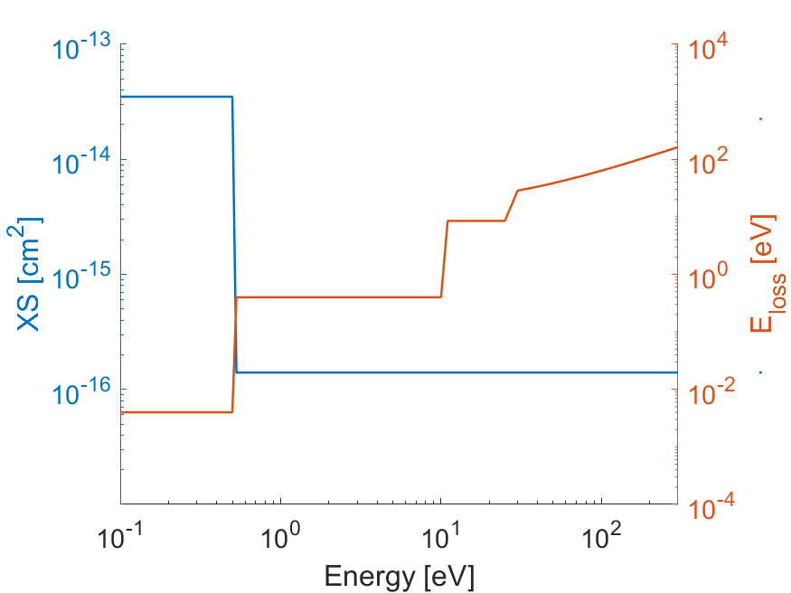

Energy Range [eV] | Process | XS [cm²] | E_{loss} [eV]
< 0.4 | Rotational | 3.5 x 10⁻¹⁴ | 0.004
0.4– 10 | Vibrational | 1.4 x 10⁻¹⁶ | 0.4
10 – 25 | Electronic | 1.4 x 10⁻¹⁶ | 8.5
> 25 | Ionization | 1.4 x 10⁻¹⁶ | $$13.5+\frac{1}{2}E$$

Treatment of rotational collisions
- Rotational cross section substantially higher than for other processes. Would create bottle neck for the collisional processes.
- Not important for cooling down to 0.4 eV.
- Can be treated through CSDA or neglected.

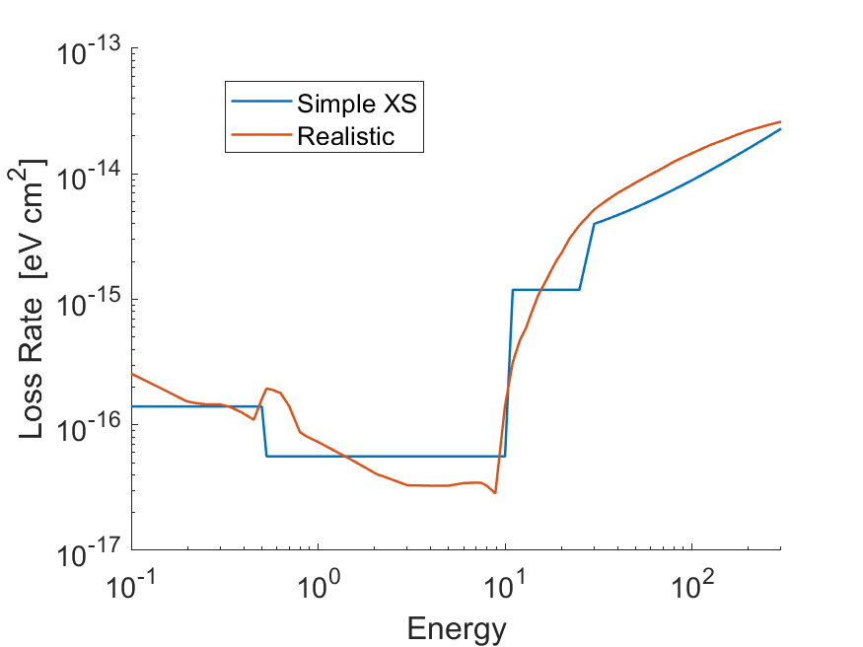
Figure 1: Comparison of loss rates using the realistic cross sections (Itikawa and Mason, 2005) and the simplified cross sections. Generally a good fit over the range 0.1 - 300 eV. Outside this range the fit is less good but there are few electrons.
Loss Rate: $LR=σ\left(E\right)×E_{Loss}$
Only one process per energy and the cross section is constant for each process. Energy loss is constant for first three processes. For ionization, energy loss scales linearly with energy.

Collision Probability

$$P_{coll}=1-\exp\left[-nσ α vdt\right]$$
Where $σ=σ\left(E\right)$ is the collision cross section.

Correction for electron mass
The ratio, $α={\left(m_{real}/m_{heavy}\right)}^{0.5}$, corrects for the difference in path length that is caused by the artificially large electron mass. NB: This does not correct for differences in electron transport that arise from the enhanced electron mass.
Could be simplified using Taylor expansion to save on computation time.
If collisions only computed every K steps:
$$P_{coll}=1-\exp\left[-nσ α K v dt\right]$$
Here, we accept some inaccuracy of the cross section and path length as the electron moves in the K steps. Need electron depth to stay small over K steps – otherwise multiple collisions.
Issue: collision probability has to be calculated independently for each particle as it is dependent on the particle speed and the position of the particle (through neutral density).
NB. The number of skipped points should be chosen with care. Don’t want to only apply collisions in the same part of the gyration (i.e. when electrons are at an energy max or min in ExB drift). Should still have collisions checked at multiple points throughout an electron gyration.
- Could potentially speed up the calculation of probability with (1st or 2nd order) taylor series as $τ_{e}=-nσKvdt$ should be small for each step. May be just as quick to use exponential.
TODO: Need to choose a threshold collision probability per step. This can be used as a warning and to set the value of K dynamically. To be tested with the test pl model??
- Maximum $P_{coll}$ should be ensured below threshold (~0.3). Need testing to choose the threshold.
- For testing – need dt in PiC

Does a collision occur?
Generate random number, $R_{coll}$ , for each particle in interval [0,1]. Collision occurs if
$$R_{coll}<P_{coll}$$
Could generate 100 (up to Npls in the node) rand no. simultaneously. And then use these for the sequential pls.
Issue: Requires loop over all particles as each has different collision probability. Random number for each macroparticle.

Implement collision
Reduce particle energy and scale velocity.
$$E_{new}=E_{old}-E_{loss}$$
$$v_{new}=\sqrt{\frac{E_{new}}{E_{old}}}×v_{old}$$
No scattering of the electrons in this implementation.
NB. Can’t reliably use Taylor expansion here as the energy loss is often comparable to the electron energy.

Create Secondary Electrons and Ions
If e-impact ionization, then need to produce new ion and electron. (see Mercury)
Separate module for ionization processes.
Collision occurs at position $x_{coll}$.
Cometary ion sampled from 0.1 eV Maxwellian – same as used in photoionization. Generated at position of collision.
Q: Is there a problem producing multiple particles at the same position? No as long as they have diff velocities.
Secondary Electron: Produced at $x_{coll}$ with an energy of $E_{new}$. (could use magnitude of velocity from incident electron)
Issue: If producing electron and ion from an ionization site, may be tricky in terms of moving between species. In PiC, each species is pushed sequentially. Generating new ions and electrons may create some issues/backlog?

Todo: Choose distribution of energy between scattered and secondary electrons.
- Could use 1/3 vs 2/3? Or some distribution between 0 and 1?
- Highest energy goes to initial pl. Then secondary electron is produced with random velocity.
- Particle velocity initialised in random direction using two random no.s $R_{θ},R_{ϕ}$ from [0,1]
$θ_{v}=\cos^{-1}\left(2R_{θ}-1\right)$ and $ϕ_{v}=2πR_{ϕ}$

Correction for the electron mass
- For an electron of given energy $E$, what is the path length?
- Gyroradius given by $r_{gyro}=mv/qB$
- Inserting $v=\sqrt{2E/m}$, gives $r_{gyro}∝m^{0.5}$
- Do we care about the path length for the gyroradius? Or are we more interested in the velocity of the pl?
  - Should be tested with the test pl model.

Normalization for the cross-section value
- Normalisation is used in the PiC model to improve precision.
- Distances normalised to inertial length of proton $\tilde{d_{p}}$
- Velocities normalised to speed of light $c$
- Speed of light in PiC simulation sometimes reduced.
- Key: Variable in code units $ϕ$, physical value of var $\overline{ϕ}$ and normalisation value $\tilde{ϕ}$
  - $\overline{ϕ}=ϕ\tilde{ϕ}$
- E.g., $\overline{x}=\tilde{d_{p}}x$
- Normalising the equations used for collision processes

Ionization Frequency
Continuity equation given by:
$$\frac{1}{{\overline{r}}^{2}}\frac{\text{d}}{\text{d}\overline{r}}\left({\overline{n}}_{i}{\overline{r}}^{2}\overline{u_{i}}\right)={\overline{ν}}_{ioni}{\overline{n}}_{n}$$
$$\frac{\tilde{c}}{\tilde{d_{p}}}\frac{1}{r^{2}}\frac{\text{d}}{\text{d}r}\left(n_{i}r^{2}u_{i}\right)=ν_{ioni}\tilde{ν_{ioni}}n_{n}$$
$$\tilde{ν_{ioni}}=\frac{\tilde{c}}{\tilde{d_{p}}}$$

Neutral Density and Outgassing
From Haser Model:
$${\overline{n}}_{n}=\frac{\overline{Q}}{4π\overline{u_{g}}{\overline{r}}^{2}}$$
$${\tilde{n}}_{n}=\frac{\tilde{Q}}{c{\tilde{d_{p}}}^{2}}$$
NB that Charge density is normalised to:
$$\tilde{ρ}={\left(\tilde{\frac{q}{m}}\right)}^{-1}\left(\frac{c^{2}}{\tilde{{d_{p}}^{2}}}\right)$$
Therefore using
$$\tilde{n_{n}}=\frac{c^{2}}{\tilde{{d_{p}}^{2}}}$$
Outgassing is normalised to
$$\tilde{Q}=c^{3}$$

Collision Probability and cross sections
Starting from the equation for collision probability:
$$P_{coll}=1-\exp\left[-{\overline{n}}_{n}\overline{σ}\overline{v}\text{d}\overline{t}\right]$$
$$P_{coll}=1-\exp\left[-n_{n}\tilde{n_{n}}\tilde{σ}σ\tilde{c}v\text{d}t\tilde{t}\right]$$
With $\tilde{t}=\frac{\tilde{d_{p}}}{c}$
$$\tilde{n_{n}}\tilde{σ}\tilde{c}\tilde{d_{p}}/c=1$$
$$\frac{c^{2}}{\tilde{{d_{p}}^{2}}}×\tilde{σ}c\tilde{d_{p}}/c=1$$
$$\tilde{σ}=\frac{\tilde{d_{p}}}{c^{2}}$$

What is the proton inertial length?
Proton inertial length is
$$d_{p}=\frac{c}{ω_{pi}}$$
$$\overline{ω_{pi}}={\left(\frac{4π{\overline{n}}_{i}Z_{i}^{2}{\overline{e}}^{2}}{m_{p}}\right)}^{2}$$

Another thing to normalise/correct for:
What are the threshold energies etc? in normalised code units?
What is the pl mass in the code units also?
Only charge over mass ratio is set for each particle.
What is the charge of an electron? When normalised? Does that even make sense?

Want to add timer for collisional processes.

How are particles created in the PiC simulation??

Aligned_vector(speciesParticle) vector_SpeciesParticle; - creates Larray of type SpeciesParticle
Found in Larray.h

Questions to ask?
How to normalise the electron mass, calculate energy of a specific pl.
How to normalise energies? – related to mass normalisation

Collisions seem to be working at low energies (purely inelastic) but haven’t included them in full simulations yet.
However, issues occur when Ionization happens. Can save and inject new pls reasonably well. BUT the energies of pls skyrocket over a short number of cycles. Could be a bug in the code I’ve written OR could be driven by the fields which arise from the injection of new electrons/ions into the domain. – Especially for infrequent/localised process.

Normalisation for the Cross Sections
The solar wind density is normalised to $1/4π$, which also gives the normalisation for the neutral density.
$$\overline{n_{SW}}=n_{SW}\tilde{n}$$
With $n_{SW}=1/4π$. Therefore,
$$\tilde{n}=4π\overline{n_{SW}}$$
For cometary applications, we have been using $\overline{n_{SW}}=1$cm⁻³ at the upstream boundary.
The neutral density in the code should therefore be normalised as
$$n_{n}=\frac{{\overline{n}}_{n}}{\tilde{n}}$$

Normalising the outgassing
From the Haser model
$${\overline{n}}_{n}=\frac{\overline{Q}}{4π\overline{u_{g}}{\overline{r}}^{2}}$$
$$\tilde{n}=\frac{\tilde{Q}}{c{\tilde{d_{p}}}^{2}}$$
As such,
$$\tilde{Q}=\tilde{n}c{\tilde{d_{p}}}^{2}$$

Collision Probability and cross section
Starting from the equation for collision probability:
$$P_{coll}=1-\exp\left[-{\overline{n}}_{n}\overline{σ}\overline{v}\text{d}\overline{t}\right]$$
$$P_{coll}=1-\exp\left[-n_{n}\tilde{n_{n}}\tilde{σ}σ\tilde{c}v\text{d}t\tilde{t}\right]$$
With $\tilde{t}=\frac{\tilde{d_{p}}}{c}$
$$\tilde{n}\tilde{σ}\tilde{c}\tilde{d_{p}}/c=1$$
$$\tilde{σ}=\frac{1}{\tilde{n}\tilde{d_{p}}}$$

Energy of particles in the simulation
Kinetic energy of electrons in physical domain given by:
$$\overline{E}=\frac{1}{2}m{\overline{v}}^{2}$$
In the simulation code, pls have a charge over mass ratio (QOM) rather than a mass
$$E=\frac{1}{2\left|QOM\right|}v^{2}$$
The protons in the solar wind have a QOM = 1.

Normalising for the energy

How to test the energy loss rate.
Want to keep electrons in the box for a reasonable time

What value should it tend to?
For secondary ions and SW electrons?

